Skilled to Build: Developing the Future Manufacturing Workforce

Grant Project Proposal Packet

Responses due: October 31st, 2022, by 5:00 PM

Office Contact Information:
Daniel Hofmann, Finance Manager | IMEC
801 West Main Street, Peoria IL 61606
Phone: 309-677-4625
Email: grants@imec.org

The Illinois Manufacturing Excellence Center (IMEC) and the Illinois Manufacturers’ Association (IMA) Education Foundation are community partners whose missions are to drive productivity and competitiveness of Illinois manufacturers. IMEC and the IMA Education Foundation designed this grant program to engage community college faculty to advance the understanding and the application of innovative workforce solutions for Illinois small and mid-sized manufacturers (defined as 500 employees or less). Funding is available for up to $50,000 per project.
Successful submissions will clearly articulate the importance and practical benefits of the proposed project for small and mid-sized Illinois manufacturers. Project outcomes are required and may include webinars, workforce training programs, manufacturer projects, manufacturer education, service development, and events, among other solutions.

This funding is made possible by the U.S. Department of Commerce’s Manufacturing Extension Partnership program for the purposes of addressing workforce challenges experienced by Illinois manufacturers.

Grant Overview
- Eligible applicants are faculty in any discipline at Illinois community colleges
- Up to $50,000 in funding for each project with required 1:1 non-federal match
- Projects and activities must be Illinois based
- Funding cannot be used for expenditures prior to the award
- Funding cannot be used for capital equipment (as defined in 2 CFR 200.1)
- Projects must be completed by November 30th, 2023

Timeline
- September 15th – October 31st, 2022: Applications accepted
- November 1st – November 30th, 2022: Review/selection with input from IMEC Board of Directors (industry leaders)
- December 2022: Award/Contracting
- January – November 2023: Contract performance period

Proposal Scoring Criteria
- Project addresses a clearly defined need for manufacturing
- Overall proposal clarity and completeness, with defined project outputs
- Likelihood of success
- Demonstrated support, input, or collaboration with Illinois manufacturers
- Scalability of the proposed approach
- Defined collaboration with IMEC
- Qualifications of applicants

Project Name:
Project Lead Name:
Title:
College Name:
Physical Address:
Email Address:
Phone:

Executive Summary
Please give a summary of your proposed project that is no more than 250 words.
Project Description
Please provide an outline that details the purpose of the project and project objectives in a structured format covering all stages of the project using no more than two pages.
Manufacturer Involvement
Please articulate how manufacturers will be included and/or directly served by your proposed project using no more than one page.
Scope of Work
Please include a list of specific project goals, deliverables, and tasks to be completed during your proposed project period using no more than one page.
Project Timeline
Please provide a chronological list of tasks and events within your project from start to finish using no more than one page.
Team Bios
Please provide a half page bio of each project contributor that includes applicable background (including any involvement with manufacturers), qualifications, and certifications.
Budget
(Use provided template)
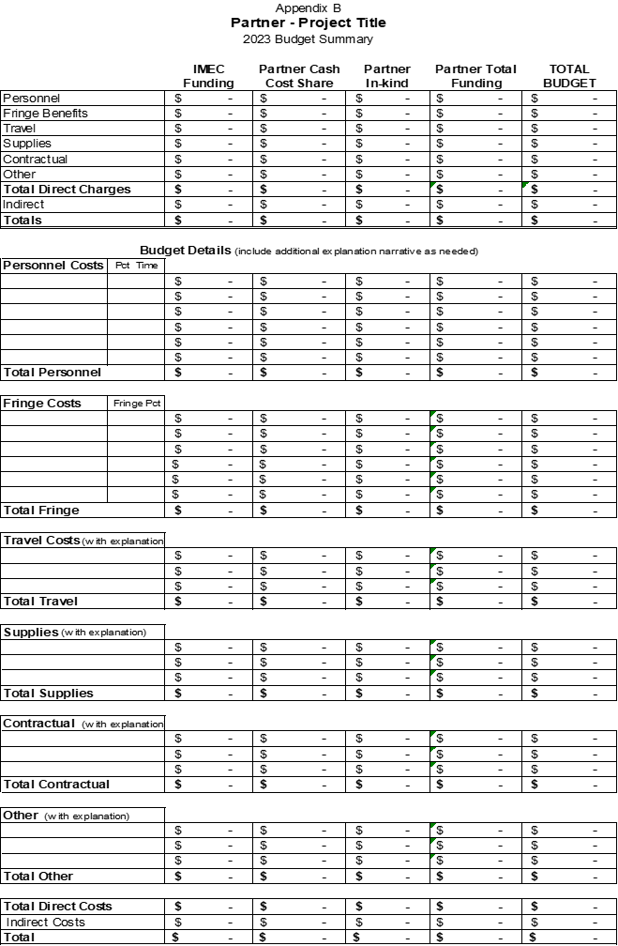

Example

Budget Justification
Please provide a narrative explanation of your proposed project budget using no more than one page.
Personnel & Fringe:

Travel:

Supplies:

Contractual:

Other:

Manufacturer Letters of Support
Optional: Include no more than two letters of support from manufacturers that articulate how your proposed project would serve manufacturing.

